https://www.geeksforgeeks.org/problems/print-square-wall-1605682270/1

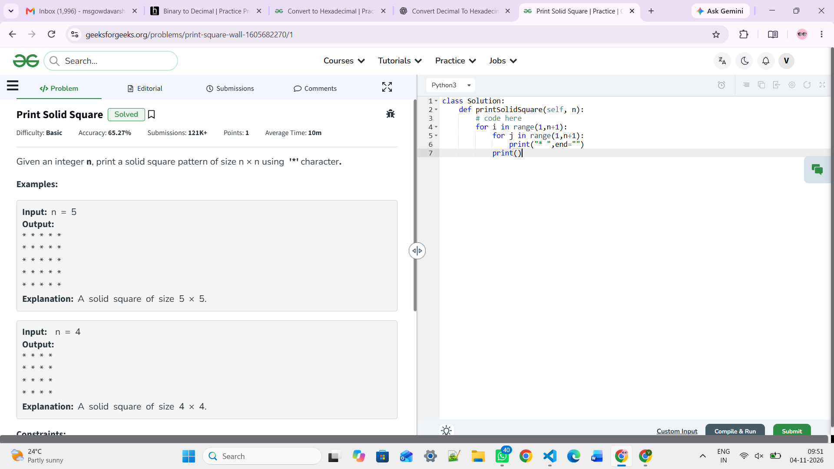

https://www.geeksforgeeks.org/problems/right-angled-number-triangle/1
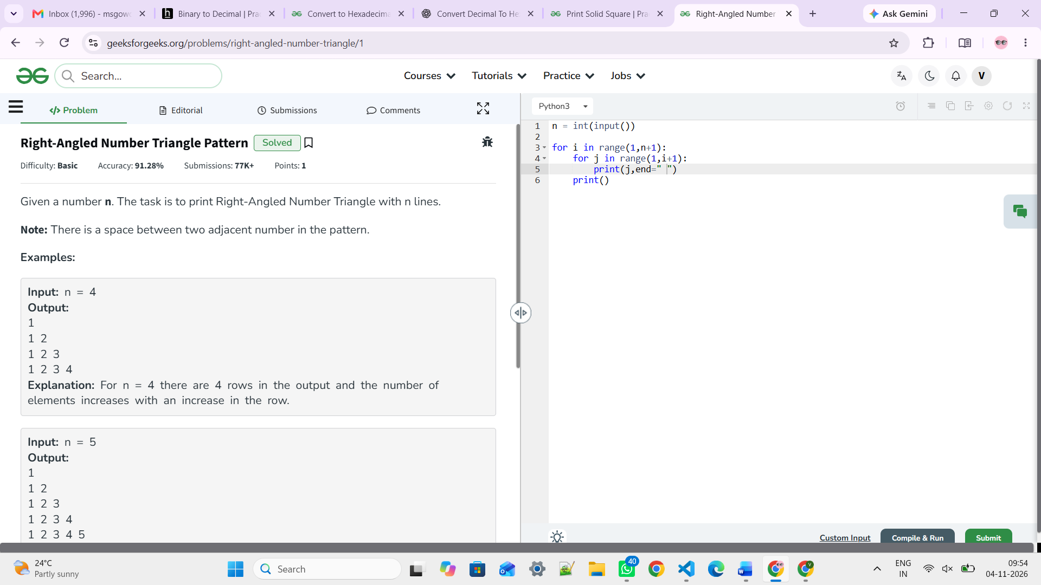

https://www.geeksforgeeks.org/problems/floyds-triangle1222/1
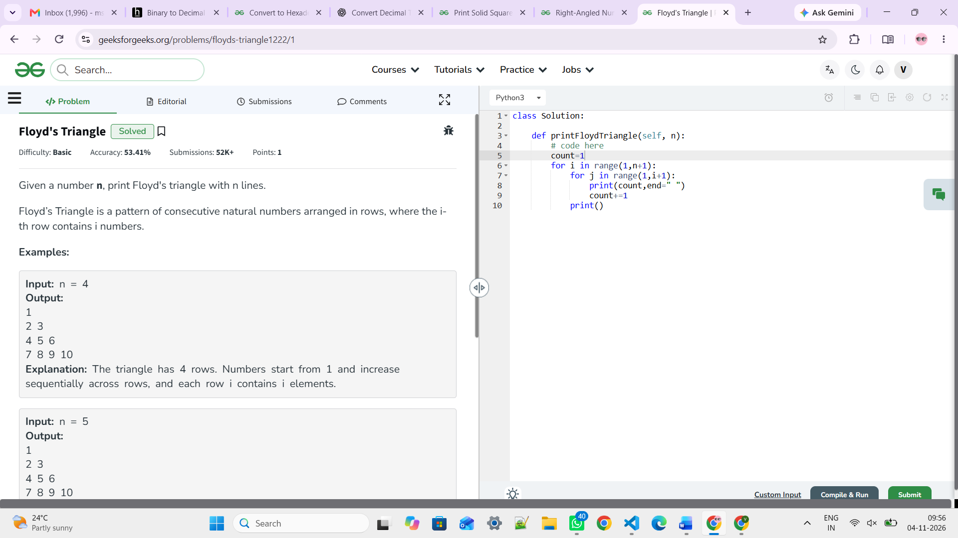

https://www.geeksforgeeks.org/problems/inverted-right-angletriangle-1605691171--104349/1

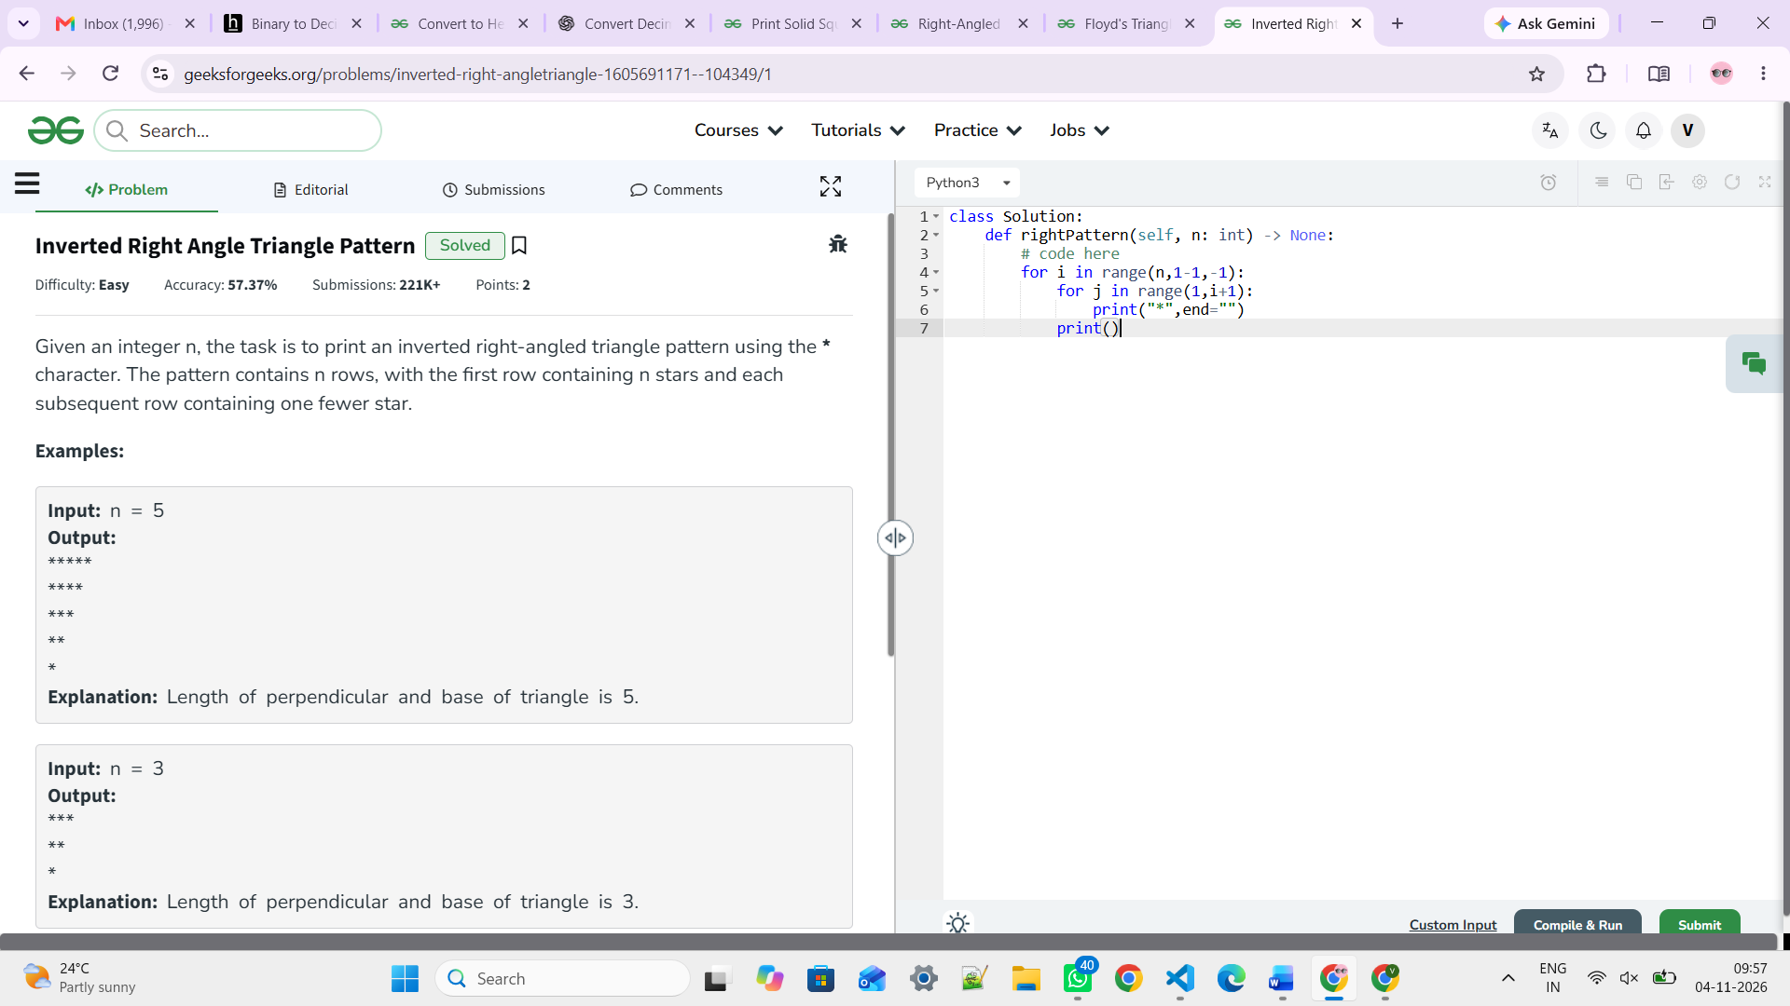

https://www.geeksforgeeks.org/problems/double-triangle-pattern-1662664259/1

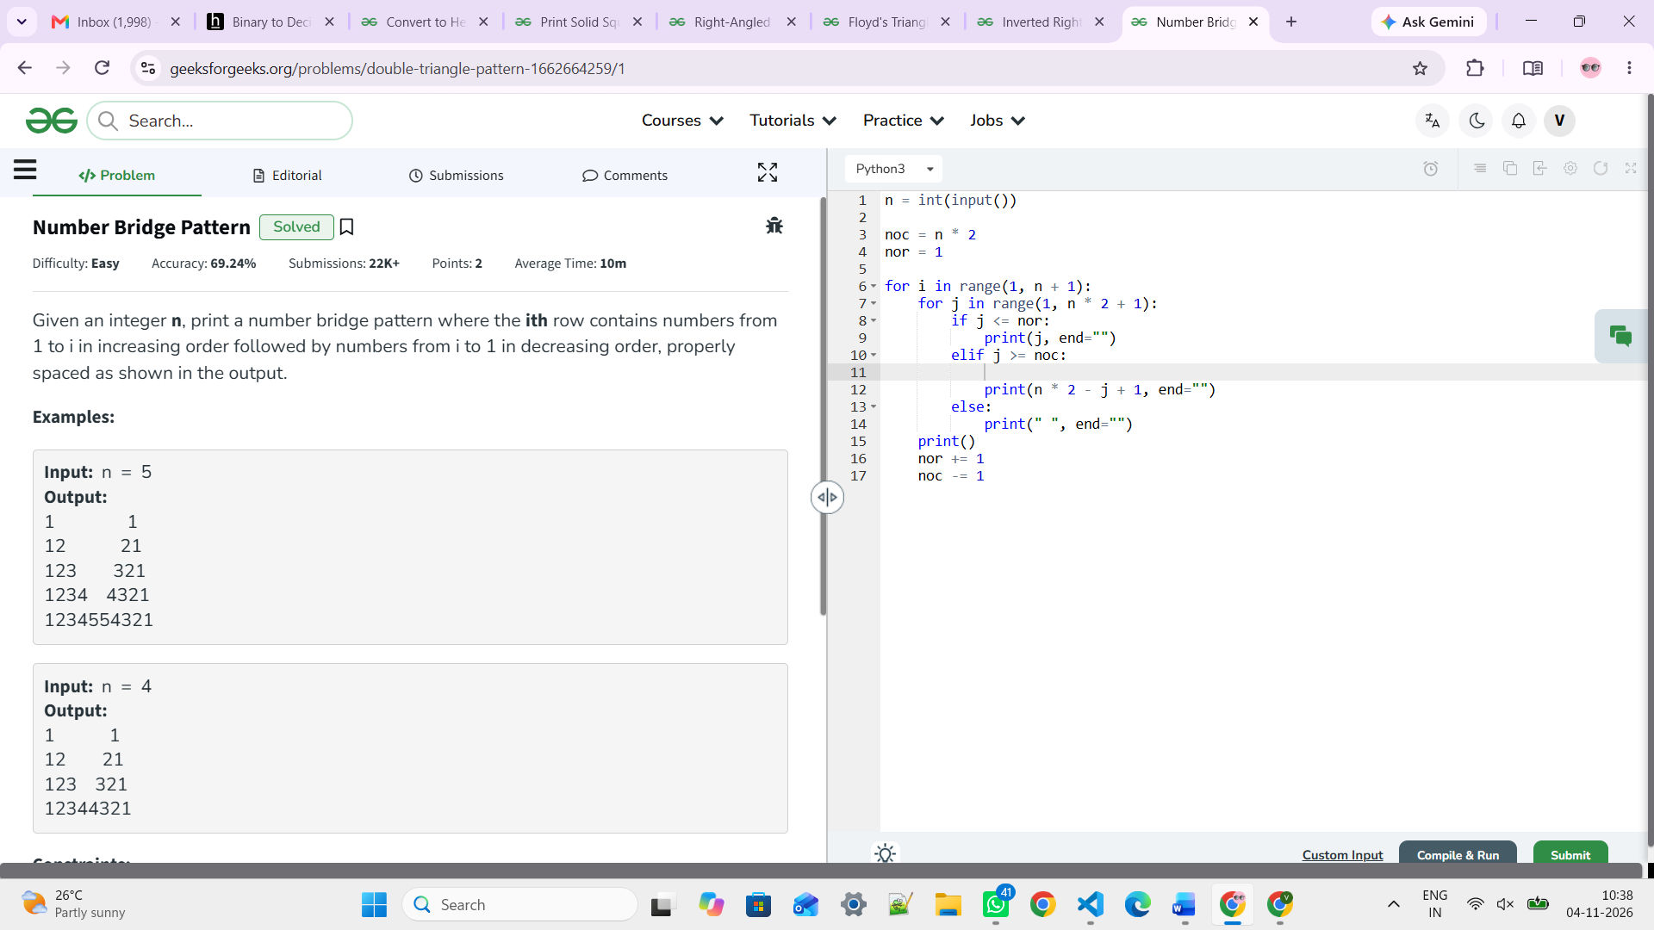

n = int(input())

noc = n * 2
nor = 1

for i in range(1, n + 1):
for j in range(1, n * 2 + 1):
if j <= nor:
print(j, end="")
elif j >= noc:

print(n * 2 - j + 1, end="")
else:
print(" ", end="")
print()
nor += 1
noc -= 1

https://www.geeksforgeeks.org/problems/pattern/1
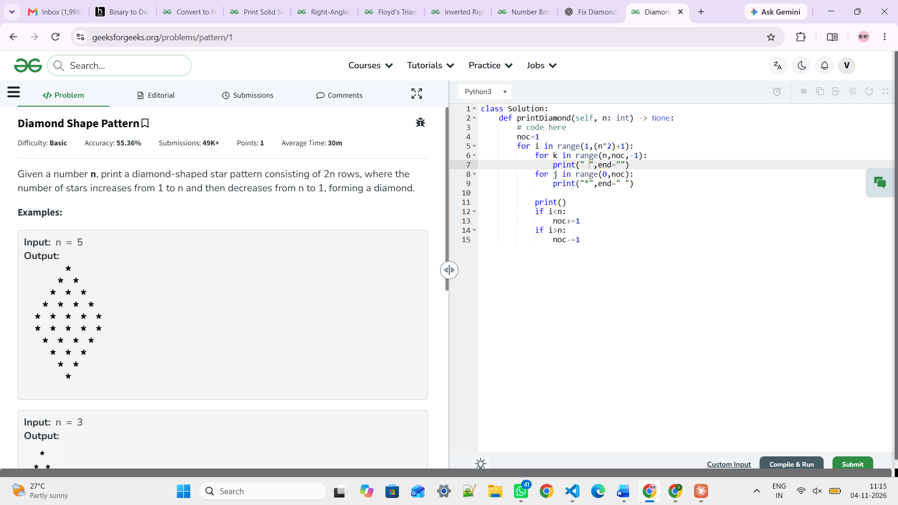
class Solution:
def printDiamond(self, n: int) -> None:
# code here
noc=1
for i in range(1,(n*2)+1):
for k in range(n,noc,-1):
print(" ",end="")
for j in range(0,noc):
print("*",end=" ")

print()
if i<n:
noc+=1
if i>n:
noc-=1
https://www.geeksforgeeks.org/problems/butterfly-pattern/1

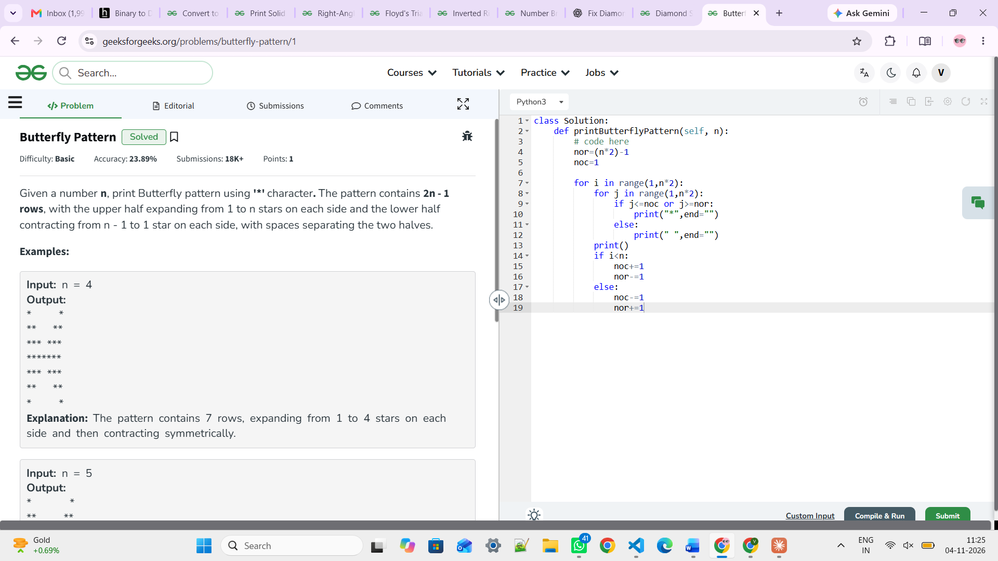

class Solution:
def printButterflyPattern(self, n):
# code here
nor=(n*2)-1
noc=1

for i in range(1,n*2):
for j in range(1,n*2):
if j<=noc or j>=nor:
print("*",end="")
else:
print(" ",end="")
print()
if i<n:
noc+=1
nor-=1
else:
noc-=1
nor+=1

https://www.geeksforgeeks.org/problems/sum-all-array-elements/1

class Solution:
def arraySum(self, arr):
result=0
for ele in arr:
result+=ele

return result

https://leetcode.com/problems/running-sum-of-1d-array/description/

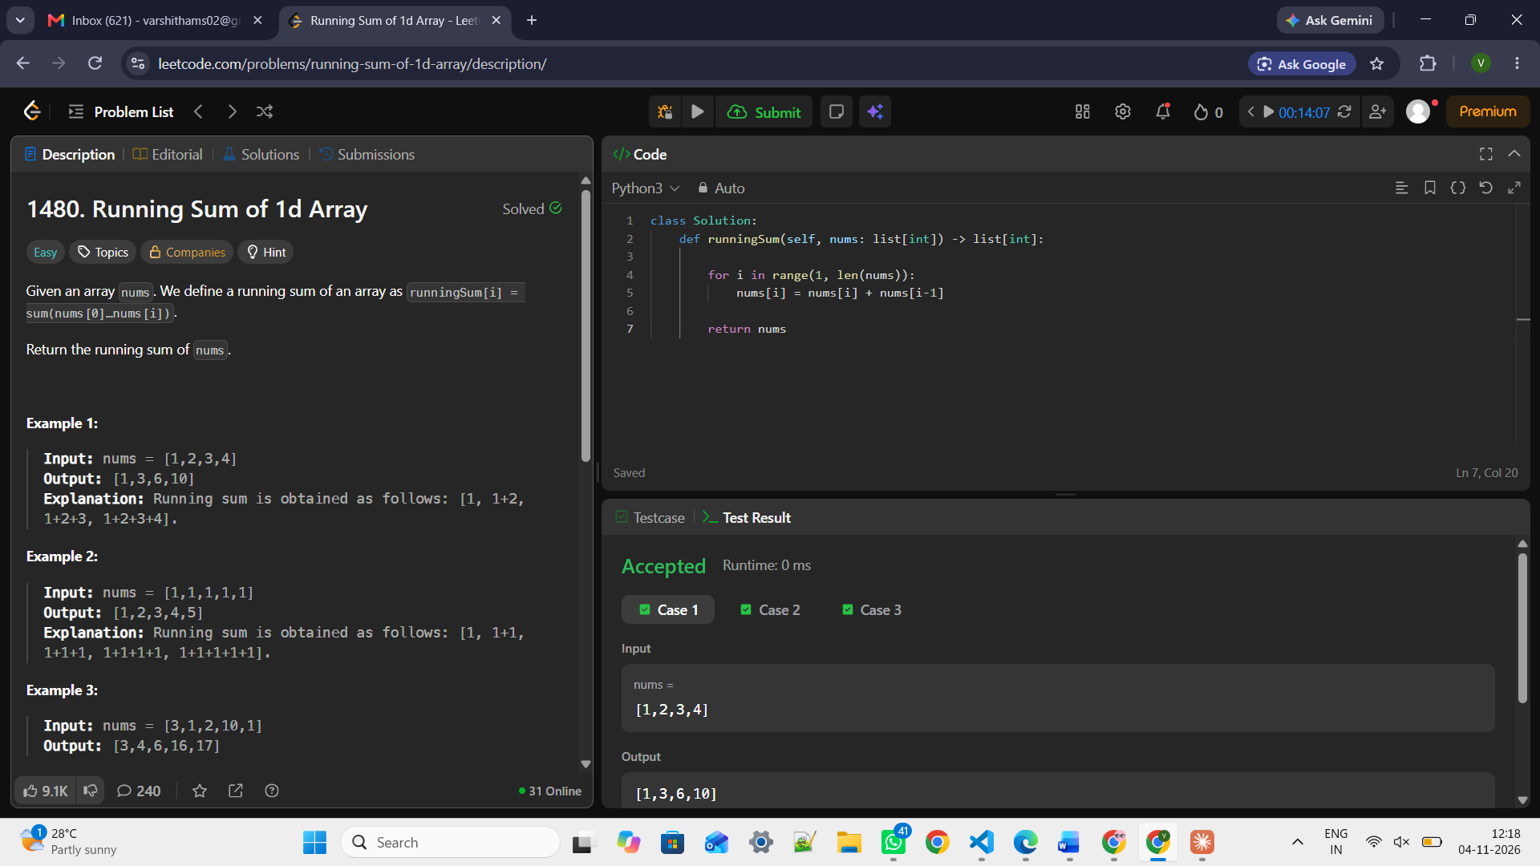

class Solution:
def runningSum(self, nums: list[int]) -> list[int]:

for i in range(1, len(nums)):
nums[i] = nums[i] + nums[i-1]

return nums

https://www.geeksforgeeks.org/problems/mean0021/1
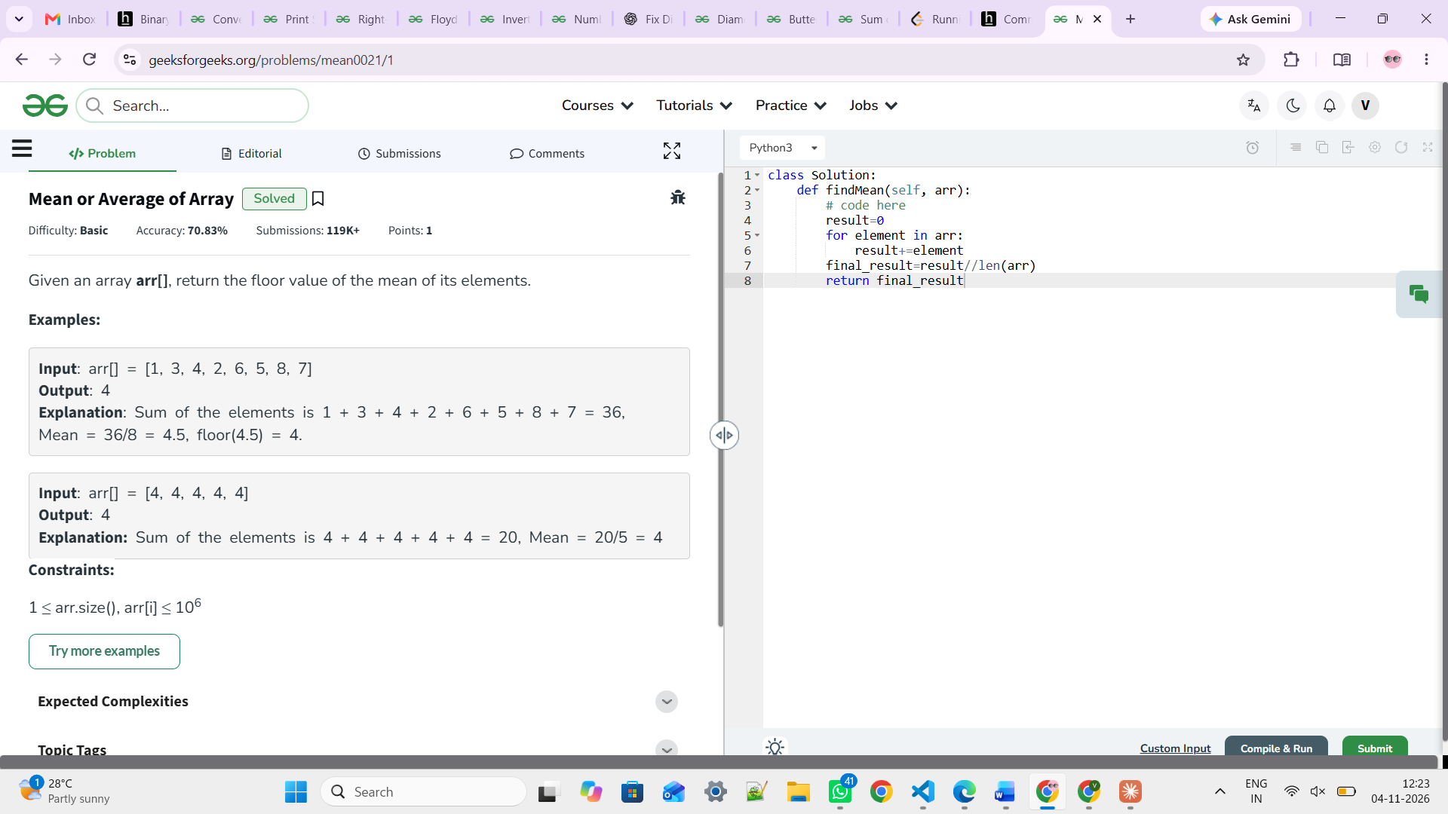

class Solution:
def findMean(self, arr):
# code here
result=0
for element in arr:
result+=element
final_result=result//len(arr)
return final_result

https://www.geeksforgeeks.org/problems/largest-element-in-array4009/1
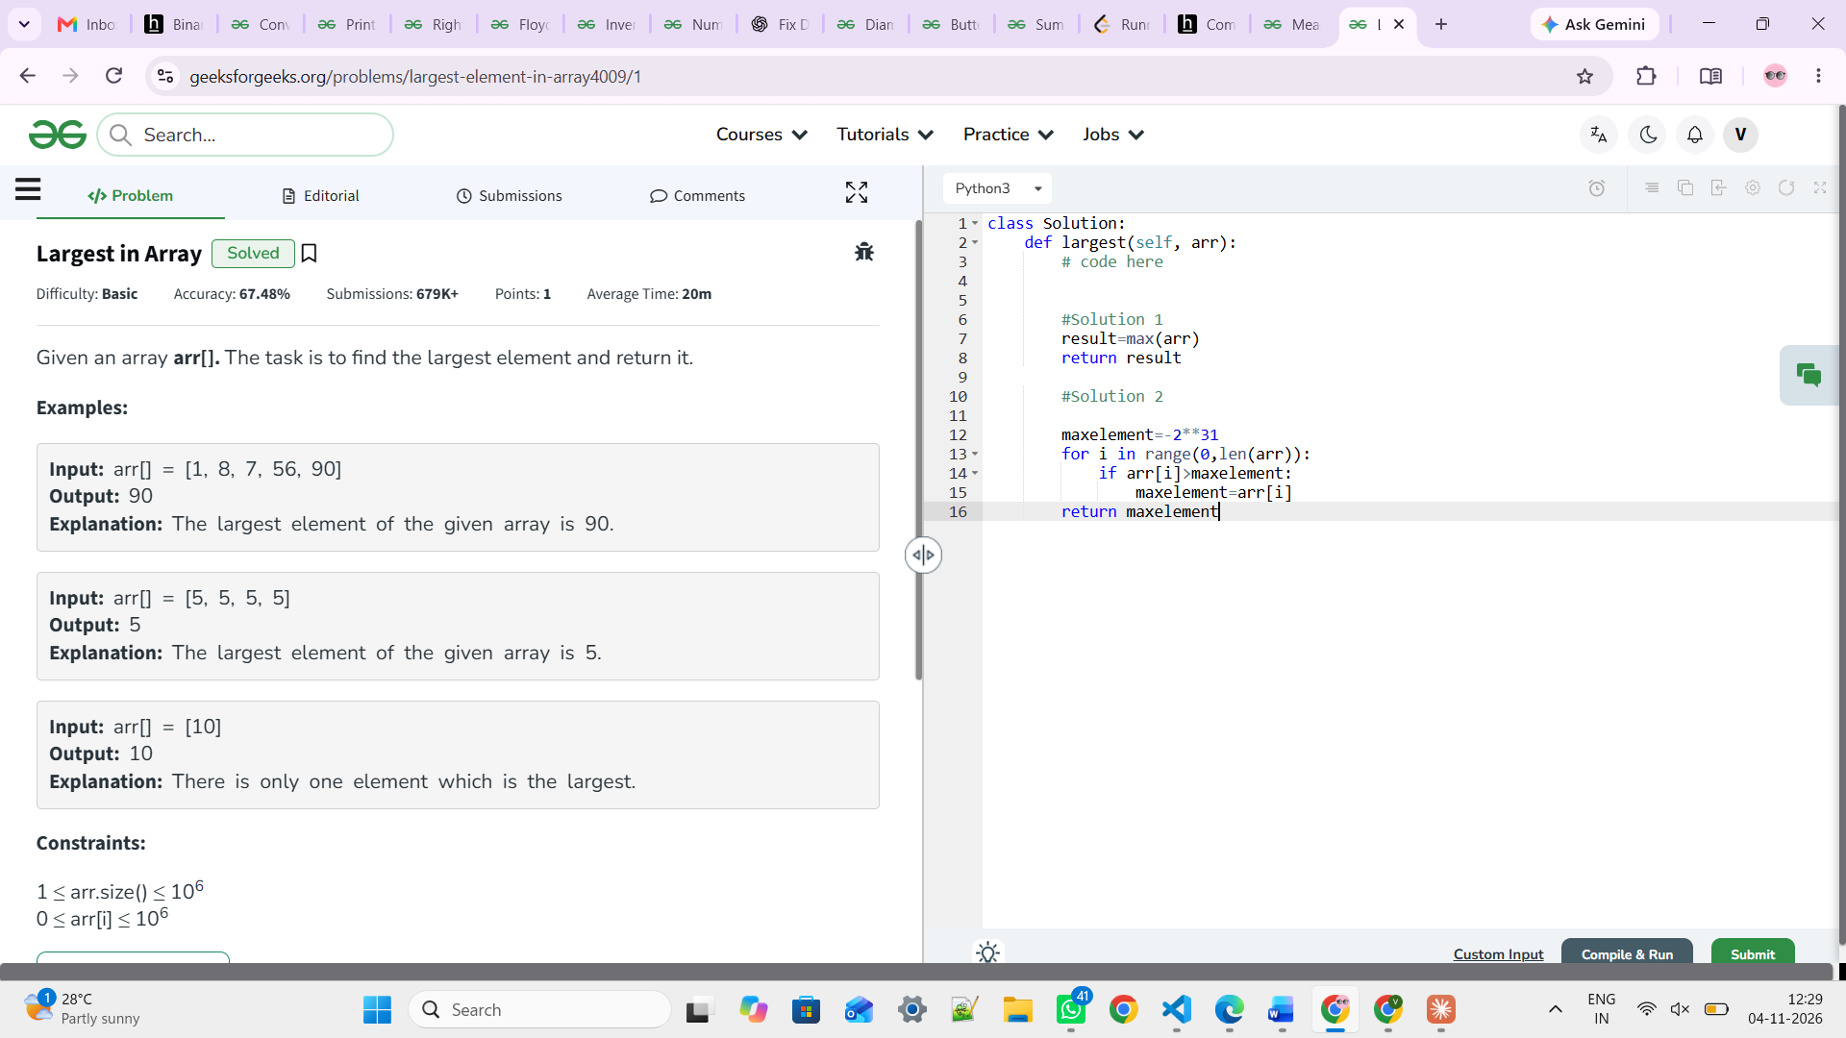

class Solution:
def largest(self, arr):
# code here

#Solution 1
result=max(arr)
return result

#Solution 2

maxelement=-2**31
for i in range(0,len(arr)):
if arr[i]>maxelement:
maxelement=arr[i]
return maxelement

https://www.geeksforgeeks.org/problems/find-minimum-and-maximum-element-in-an-array4428/1
class Solution:
def getMinMax(self, arr):
# code here
max_element,min_element=-2**31,2**31

for i in range(0,len(arr)):
if arr[i]>max_element:
max_element=arr[i]
if arr[i]<min_element:
min_element=arr[i]

return [min_element,max_element]



